 | 7.0.3 Editors - 3D View - Mesh Object - Edit Mode - Edge Context Menu
Table of content
Detailed table of content 1
Edge Context Menu 5
Subdivide 5
Extrude Edges 6
Bevel Edges 7
Make Edge/Face 11
Bridge Edge loops 11
Fill 12
Loop Cut and Slide 12
Offset Edge Slide 13
Knife Topology 14
Rotate Edge CW 15
Edge Split 15
Edge Crease 16
Edge Bevel Weight 16
Mark Sharp 16
Clear Sharp 17
Set sharpness by Angle 17
Mark Freestyle Edge 17
Clear Freestyle Edge 18
Un-Subdivide 18
Split 18
Separate submenu 18
Dissolve Edges 18
Delete Edges 19
Show/Hide 19

Detailed table of content

Detailed table of content
Detailed table of content 1
Edge Context Menu 5
Subdivide 5
Last Operator Subdivide 5
Number of Cuts 5
Smoothness 5
Create N-Gons 6
Quad Corner Type 6
Fractal 6
Along Normal 6
Random Seed 6
Extrude Edges 6
Last Operator Extrude Only Edges and Move 6
Flip Normals 6
Move X Y Z 6
Orientation 6
Constraint Axis 6
Mirror Editing 6
Proportional editing 6
Proportional Falloff 7
Proportional Size 7
Connected 7
Projected(2D) 7
Bevel Edges 7
Last Operator Bevel 7
Affect 7
Width Type 7
Width 7
Segments 8
Profile Shape 8
Material Index 8
Harden Normals 8
Clamp Overlap 8
Loop Slide 8
Mark 8
Seams 8
Sharp 8
Miter Type 8
Miter Outer 8
Sharp 8
Patch 8
Arc 8
Inner Miter 9
Sharp 9
Arc 9
Spread 9
Intersection type 9
Grid Fill 9
Cutoff 9
Face Strength 9
None 9
New 9
Affected 10
All 10
Profile Type 10
Superellipse 10
Custom 10
Presets 10
Navigation elements 10
Zoom in and out 10
Reverse Path 10
Toggle Profile Clipping 10
Tools menu 10
Reset View 10
Reset Curve 10
Handler and node position 10
Sample straigt edges 10
Sample even length 11
Make Edge/Face 11
Bridge Edge loops 11
Last Operator Bridge Edge loops 11
Connect Loops 11
Merge 11
Merge Factor 11
Twist 11
Number of Cuts 12
Interpolation 12
Smoothness 12
Profile Factor 12
Profile shape 12
Fill 12
Last Operator Fill 12
Beauty 12
Loop Cut and Slide 12
Last Operator Loop Cut and Slide 12
Number of Cuts 13
Smoothness 13
Falloff 13
Factor 13
Even 13
Flipped 13
Clamp 13
Mirror Editing 13
Correct UV's 13
Offset Edge Slide 13
Last Operator Offset Edge Slide 13
Cap Endpoint 14
Factor 14
Even 14
Flipped 14
Clamp 14
Mirror Editing 14
Correct UV's 14
Knife Topology 14
Hotkey functionality in the footer text 14
Rotate Edge CW 15
Last Operator Rotate Selected Edge 15
Counter Clockwise 15
Edge Split 15
Last Operator Edge Split 15
Type 15
Edge Crease 16
Last Operator Edge Crease 16
Factor 16
Edge Bevel Weight 16
Last Operator Edge Bevel Weight 16
Factor 16
Mark Sharp 16
Last Operator Mark Sharp 17
Vertices 17
Clear Sharp 17
Last Operator Mark Sharp 17
Vertices 17
Set sharpness by Angle 17
Last Operator Set sharpness by Angle 17
Angle 17
Extend 17
Mark Freestyle Edge 17
Clear Freestyle Edge 18
Un-Subdivide 18
Last Operator Un-Subdivide 18
Iterations 18
Split 18
Separate submenu 18
Selection 18
By Material 18
By Loose Parts 18
Dissolve Edges 18
Last Operator Dissolve Edges 19
Dissolve Vertices 19
Angle threshold 19
Face Split 19
Delete Edges 19
Show/Hide 19
Show Hidden 19
Hide Selected 19
Last Operator Hide Selected 19
Unselected 19
Hide Unselected 19

Edge Context Menu

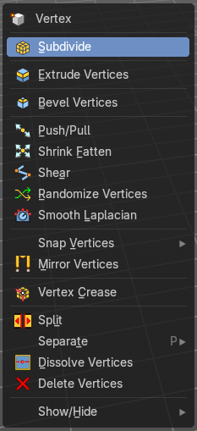
Call this menu with double right click in the 3D viewport. You need to be in Edit mode with a Mesh object. And in selection mode Edge.
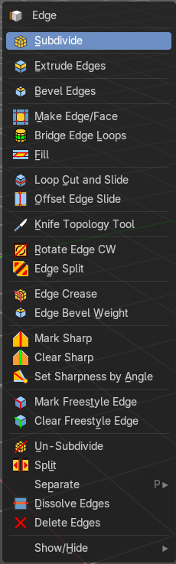
Select geometry to reveal all content.

Subdivide
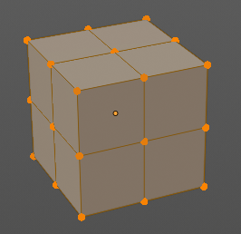
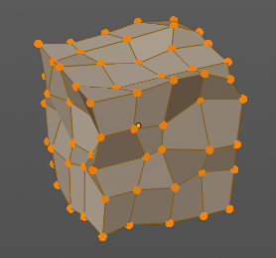
Subdivide divides the selected edges. It subdivides the involved faces too, and can create new vertices.
A more unknown functionality is that it can also randomize the result with the Fractal slider in the Last operator panel.

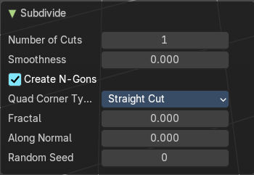
Last Operator Subdivide

Number of Cuts
The number of cuts defines the amount of subdivisions.

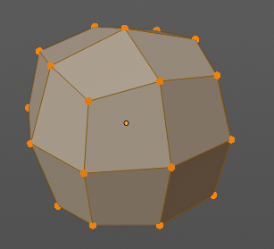
Smoothness
This value defines how smooth the subdivision result is. From flat to bent.

Create N-Gons
Create N-Gons if required. Else subdividing N-Gons creates Tris.

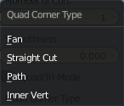
Quad Corner Type
Adjust the corner type.

Fractal
Randomize the selected vertices.

Along Normal
When randomized, this value defines how strong the subdivision follows the normals of the initial vertices.

Random Seed
Randomizing value for fractal randomizing.

Extrude Edges
Extrudes out the selected edges by moving the mouse.

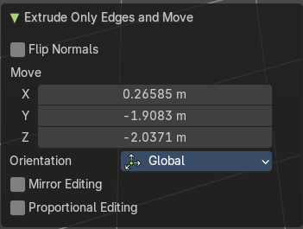
Last Operator Extrude Only Edges and Move

Flip Normals
Flip the normals at the involved faces.

Move X Y Z
The coordinates for the extruded geometry.


Orientation
Choose the type of orientation, in which coordinate system the action should happen.

Constraint Axis

Mirror Editing
Enable mirror editing.

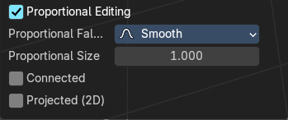
Proportional editing
Enables proportional editing. Activating proportional editing reveals further settings.

Proportional Falloff
Adjust the falloff methods.

Proportional Size
See and adjust the falloff radius.

Connected
The proportional falloff gets calculated for connected parts only.

Projected(2D)
The proportional falloff gets calculated in the screen space. Depth doesn't play a role. When it's in the radius, then it gets calculated.

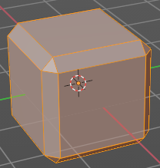
Bevel Edges
Adds a bevel at the selected edges.

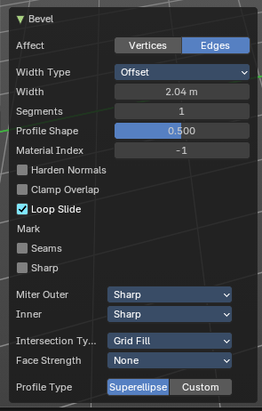
Last Operator Bevel

Affect
Affect vertices or edges.

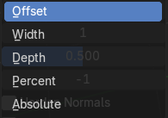
Width Type
The width type.

Width
The bevel amount.

Segments
How many segments gets created.

Profile Shape
Controls the Profile shape. 0.5 means round.

Material Index
Assigns a material slot to the new bevel faces. -1 is the surrounding material.

Harden Normals
When enabled, the per-vertex face normals of the bevel faces are adjusted to match the surrounding faces, and the normals of the surrounding faces are not affected. This will keep the surrounding faces flat (if they were before), with the bevel faces shading smoothly into them. For this effect to work, custom split normals need to be enabled, which requires Auto Smooth to be enabled (see Normals). As a convenience, that option will be enabled for you if it is not already when you enable Harden Normals here.

Clamp Overlap
Do not allow beveled geometry to overlap each other. Prevents bevel geometry from intersecting itself.
Helps avoid messy geometry in tight corners.

Loop Slide
Slides new edges along adjacent geometry for better topology flow

Mark

Seams
Mark the edges of the new created geometry as seams.

Sharp
Mark the edges of the new created geometry sharp.

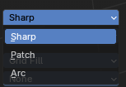
Miter Type

Miter Outer
How the outer miter is set. Miter is how the bevel rounding at a corner is done.


Sharp
Creates a sharp miter.

Patch

This replaces the outside vertex of a miter with 3 vertices. And uses a patch pattern there.

Arc

This replaces the vertex of a miter with 2 vertices, joined by an arc. A separate Spread parameter says how far to move the vertices away from their original position.

Inner Miter
How the inner miter is set. Miter is how the bevel rounding at a corner is done.

Sharp
Creates a sharp miter.

Arc
This replaces the vertex of a miter with 2 vertices, joined by an arc. A separate Spread parameter says how far to move the vertices away from their original position.

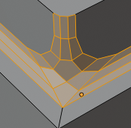
Spread
Belongs to inner miter method Arc. Adjust how strong the inner radius is bent.

Intersection type
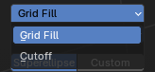
The method to use to create meshes at intersections. Bevel can create self intersecting geometry.

Grid Fill
Fills intersections with a grid-like topology.

Cutoff
Trims or removes overlapping geometry at intersections

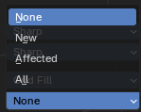
Face Strength
Set Face Strength on the faces involved in the bevel, according to the specified mode. This can be used in conjunction with a Weight Normals Modifier (with the Face Influence option checked).

None
Do not set face strength.

New
Set the face strength of new faces along edges to Medium, and the face strength of new faces at vertices to Weak.

Affected
In addition to those set for the New case, also set the faces adjacent to new faces to have strength Strong.

All
In addition to those set for the Affected option, also set all the rest of the faces of the model to have strength Strong.

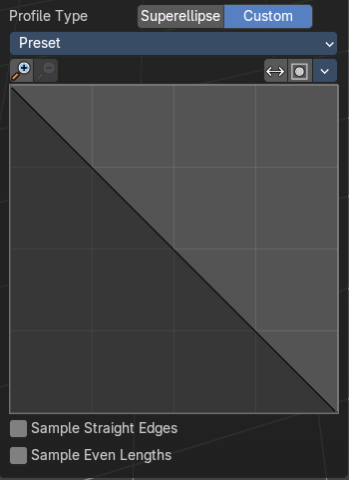
Profile Type
The profile type.

Superellipse
Uses a mathematically smooth curve for bevel profiles

Custom
Allows manual control of the bevel profile shape via a curve widget.

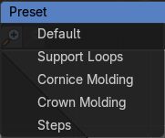
Presets
Curve presets.

Navigation elements

Zoom in and out
The two buttons with the magnifying glass at it zooms in and out in the curve window.

Reverse Path
Reverses the curve path.

Toggle Profile Clipping
Turns the profile clipping on or off.

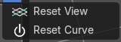
Tools menu

Reset View
Resets the curve windows zoom.

Reset Curve
Resets the curve to the initial shape.

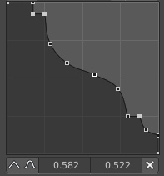
Curve view
Adjust the profile curve.
Left click where no point is adds a new point. Left click at a point allows you to move it.
Holding down Shift while moving a node point activates precision movement.
Holding down ctrl while moving activates temporary snapping.
When a point is selected then the curve view reveals a sub menu at the bottom.

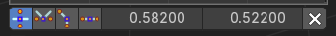
Handler and node position
When you select a node, then the handler and node position tools shows below the curve window.

Handle Type Auto Handle
Sets the handle type of this curve point to smooth.

Handle Type Vector Handle
Sets the handle type of this curve point to sharp.

Handle Type Free Handle
Sets the handle type of this curve to Free handles. The curve point has now two handles with which you can adjust the curve before and after the point each.

Handle Type Aligned Free Handle
Sets the handle type of this curve to Free handles. The curve point has now a handle with which you can adjust the curve.

X Y Values
The position of the currently selected curve point

Sample straigt edges
Sample edges with vector handles.

Sample even length
Sample edges with even lengths.

Make Edge/Face
Adds a face when you have edges selected. And Edges when you have Vertices selected. It's a Bridge tool.
You can have either the one method or the other. When you select two adjacent vertices, then you select the edge too. And the tool works in edge mode then. In this case just the possible faces gets created. Not edges between single vertices.
First select the edges or Vertices that you want to bridge. Then click the New Edge/Face from Vertices Button.
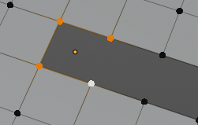
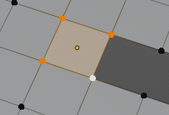
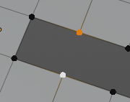
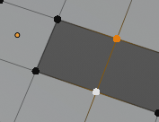

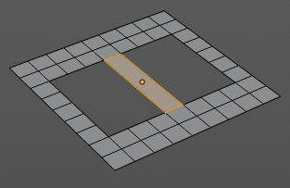
Bridge Edge loops
The Bridge edge loops tool bridges selected edges, and adds a polygon between them. You need to have at least two edges selected.

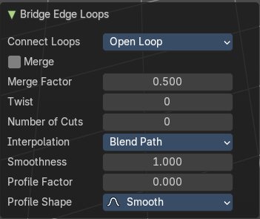
Last Operator Bridge Edge loops

Connect Loops
Choose the method how to deal with bridging multiple loops.

Merge
With merge ticked it will not create a bridge face, but merge the selected edges.

Merge Factor
The merge factor determines at which distance between the selected edges the merge happens. 0.5 is the middle of the selected edges.

Twist
The twist offset for closed loops.

Number of Cuts
Adds cuts to the bridge face.

Interpolation
Choose the interpolation mode for the cuts.

Smoothness
Adjust the smoothness for the cuts.

Profile Factor
Adjust the profile factor for the cuts.

Profile shape
Adjust the profile shape for the cuts.

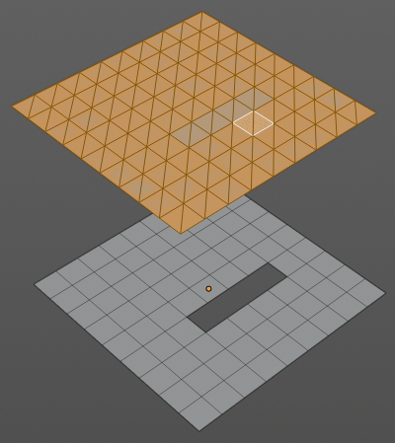
Fill
Fill closes holes in the selected mesh geometry, and triangulates the faces.

Last Operator Fill

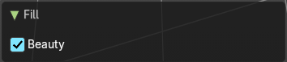
Beauty
Uses the best possible triangulation.

Loop Cut and Slide
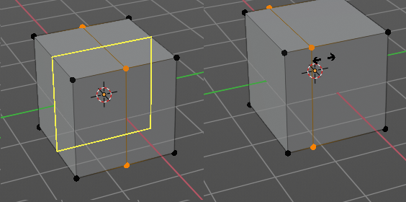
Loop Cut and Slide adds edge loops to divide faces
When you click once, then this edge gets created. When you click and hold, then you can move this edge to a new location.
Loop cut and Slide ignores selections. It will try to divide the face under the mouse, and continue the loop until it is closed, or until it cannot continue.

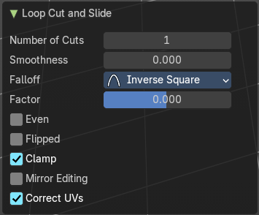
Last Operator Loop Cut and Slide
Note that all settings here just changes the latest added loop. Not all added loops in the current session.

Number of Cuts
The number of cuts that gets added. It can be more than one loop at once.

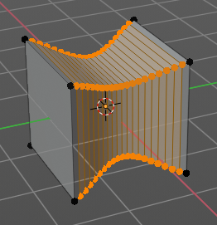
Smoothness
This value defines how smooth the loop cut gets added. From flat to bent.

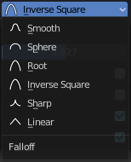
Falloff
Adjust the Falloff type for smoothness.

Factor
Change the center of the added loop.

Even
Make the edge loop match the shape of the adjacent edge loop

Flipped
When Even mode is active, flips between the two adjacent edge loops.

Clamp
Clamp within the edge extend.

Mirror Editing
Enable mirror editing.

Correct UV's
Corrects the UV's when modifying the geometry.

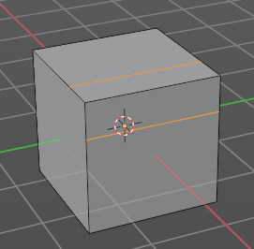
Offset Edge Slide
Adds left and right an edge from the selected edge and slides it outwards.

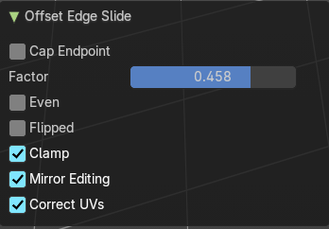
Last Operator Offset Edge Slide

Cap Endpoint
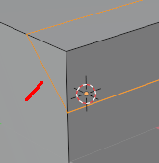
Connects the endpoints of the slided edges.

Factor
The amount of sliding.

Even
Make the edge loop match the shape of the adjacent edge loop

Flipped
Connected with Even. When even mode is active then flips between the two adjacent edge loops.

Clamp
Clamp within the edge extends.

Mirror Editing
Enable mirror editing.

Correct UV's
Correct UV coordinates when transforming.

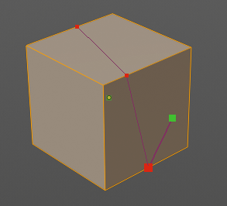
Knife Topology
The Knife tool cuts the geometry, and adds edges. When it crosses existing geometry then it adds a vertice at the crossing point.
Usage: activate the tool, left click to define the starting point. This can also be a point in the middle of a face. But ideally you choose an existing vertice or an edge as the start and endpoints. The knife tool tries to snap to them when you get close with the mouse cursor.
When done press Enter or Space bar to confirm. Right click abandons the operation.
When you create a vertice in the middle of a face, then the knife tool will try to connect this vertice by an existing vertice of this face when you confirm with space bar.

Hotkey functionality in the footer text
Have a look at the footer when you work with this tool. Here you will find further instructions and hotkeys.
Enter, Pad Enter, Space bar - confirm
Esc key, RMB - cancel the operation
LMB start the cut
Double LMB - close the cut
E - create new cut
Ctrl or Shift while dragging - Snap to the middle of an edge
Z - cut through the whole geometry, also the back faces.
MMB - pan the view.
Alt MMB - rotate the view.

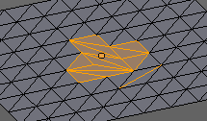
Rotate Edge CW
Rotate Edge rotates the selected edge clockwise.

Last Operator Rotate Selected Edge

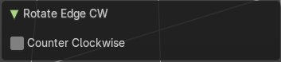
Counter Clockwise
Rotate selected edges counter clockwise.

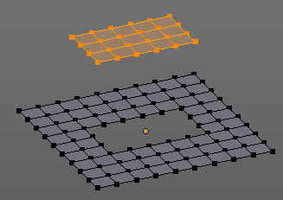
Edge Split
Splits selected edges so that each neighbor face gets its own copy. You have two methods here.

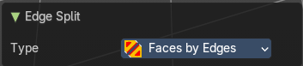
Last Operator Edge Split

Type
Choose the method again.

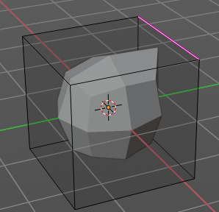
Edge Crease
When you use a Subdivision Surface Modifier, then you can define the sharpness of selected edges with this tool. Crease edges will be marked colored in edit mode.
You will see a value in the header that indicates the current strength when you activate the tool. Move with the mouse to increase or decrease the value. Or type in a value while you are in this mode. You can also scale into negative range.
A negative crease value will subtract from the current active crease value in case it exists already from a former crease operation. A Crease value of -1 removes the crease from this edge.

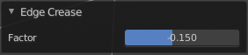
Last Operator Edge Crease

Factor
Adjust the crease factor.

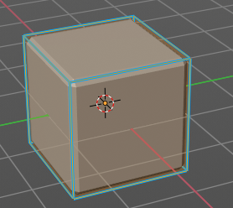
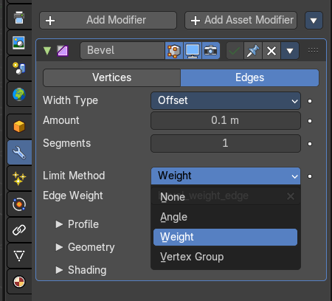
Edge Bevel Weight
This tool adjusts the edge bevel weight for selected edges when you use the Bevel modifier at the mesh.
You need to have set the limit method to Weight. This way you can achieve a bevel weight for every individual selected edge if you want, and achieve different bevel strengths at the mesh.

You will see a value in the header that indicates the current strength when you activate the tool. Move with the mouse to increase or decrease the value. Or type in a value while you are in this mode. You can also scale into negative range.
A negative Edge Bevel Weight value will subtract from the current active crease value in case it exists already from a former crease operation. An Edge Bevel Weight value of -1 removes the weight from this edge.

Last Operator Edge Bevel Weight

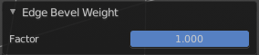
Factor
Adjust the Edge Bevel Weight factor.

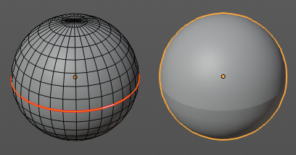
Mark Sharp
Mark Sharp is a tool that you need for the Edge Split modifier. Marked edges are displayed and rendered as sharp edges.
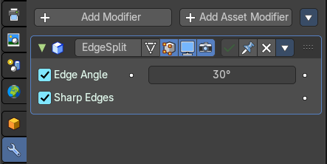

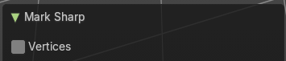
Last Operator Mark Sharp

Vertices
Calculate by the selected vertices instead of edges to mark the edges.

Clear Sharp
Clears formerly as sharp marked selected edges.

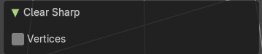
Last Operator Mark Sharp

Vertices
Calculate by the selected vertices instead of edges to mark the edges.

Set sharpness by Angle
Sets the sharpness of edges by their angle to the neighbour face.

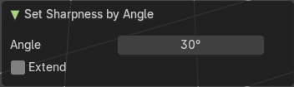
Last Operator Set sharpness by Angle

Angle
The angle after which the edge counts as sharp.

Extend
Add new sharp edges without clearing existing sharp edges.

Mark Freestyle Edge
Mark the selected edges as a Freestyle feature edges.

Clear Freestyle Edge
Clears formerly as freestyle feature edges marked edges.

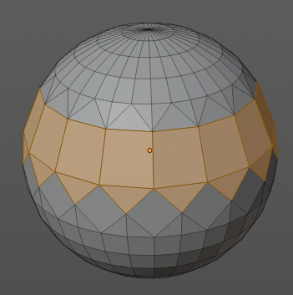
Un-Subdivide
Decimates the geometry by trying to make one quad out of four quads. But can also end in Tris where this is not possible.

Last Operator Un-Subdivide

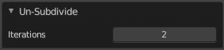
Iterations
Number of iterations. This means how deep the calculation should go. One level of SDS, two levels, three levels, etc. . Down to the point where you cannot decimate any geometry anymore.

Split
Splits the edges between the selected vertices. It creates two edges out of one. And splits the edge by that.

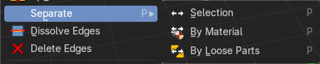
Separate submenu
Separate separates the selected geometry, and creates a new object. The geometry becomes uneditable, since it is now a new object. You will have to leave the Edit mode, select the new object, and re-enter Edit mode when you want to edit it.

Selection
Selection separates the current selection.

By Material
By Material separates all geometry that has the same material than the current selection.

By Loose Parts
By Loose parts separates all geometry that is connected by edges to the current selection.

Dissolve Edges
Dissolve Edges dissolves the selected edges.
Note that pressing DEL in Vertice select mode calls Dissolve Vertices already. It's the same operator. But you don't get the Last operator that way.

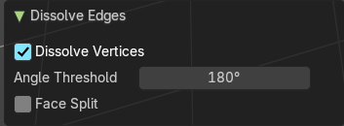
Last Operator Dissolve Edges

Dissolve Vertices
Dissolve remaining vertices which connect to only two edges.

Angle threshold
Remaining vertices which separate edge pairs are preserved if their edge angle exceeds this threshold.

Face Split
Split off Face corners to maintain surrounding geometry

Delete Edges
Deletes the selected Edges.

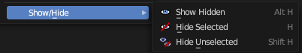
Show/Hide
Sub-menu with shows or hide selection, unselected or hidden operators.

Show Hidden
Makes all geometry in the scene visible again.

Hide Selected
Hides the selected geometry.


Last Operator Hide Selected

Unselected
Hides the not selected geometry.

Hide Unselected
Hides the not selected geometry. The selected geometry stays visible.

